Led Spotlight Drilling Templates
From: CindyBob.com Halloween Pages

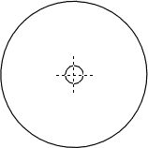

Single LED Spotlight
1” End Cap – 13/64” Holes for 5mm LED

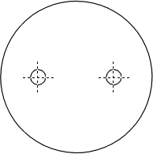

Double LED Spotlight
1 ¼” End Cap – 13/64” Holes for 5mm LED

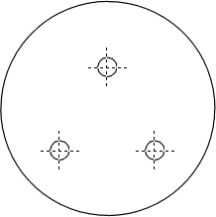

Triple LED Spotlight
1 ½” End Cap – 13/64” Holes for 5mm LED

